**DAILY ONLINE ACTIVITIES SUMMARY**

|  |  |  |  |  |  |  |  |  |
| --- | --- | --- | --- | --- | --- | --- | --- | --- |
| **Date:** | **16/06/2020** | | | | | **Name:** | **PRANEETA P HANDRAL** | |
| **Sem & Sec** | **4​th​ SEM. & ‘B’ SEC.** | | | | | **USN:** | **4AL19CS401** | |
| **Online Test Summary** | | | | | | | | |
| **Subject** | | **COMPLEX ANALYSIS,PROBABILITY AND STATISTICAL METHODS** | | | | | | |
| **Max. Marks** | | **30** | | **Score** | | | **22** | |
| **Certification Course Summary** | | | | | | | | |
| **Course** | **Blockchain Essentials** | | | | | | | |
| **Certificate Provider** | | | **Cognitive class** | | **Duration** | | | **6 Hrs.** |
| **Coding Challenges** | | | | | | | | |
| **Problem Statement:** **Write a C Program to perform the following operations on Triply Linked List (TLL).** | | | | | | | | |
| **Status:** **Executed.** | | | | | | | | |
| **Uploaded the report in Github** | | | | | **Yes** | | | |
| **If yes Repository name** | | | | | **LockdownCoding**  <https://github.com/praneetahandral/lockdowncoding> | | | |
| **Uploaded the report in slack** | | | | | **Yes** | | | |

**Online Test Summary:** 18MAT41 online test was scheduled from 3:00pm to 3:40pm .The portion for the IA was 1st module there were 30 questions and the time assigned was 40minutes the questions were MCQ type. There were 15 questions of each questions carry 2 marks respectively.

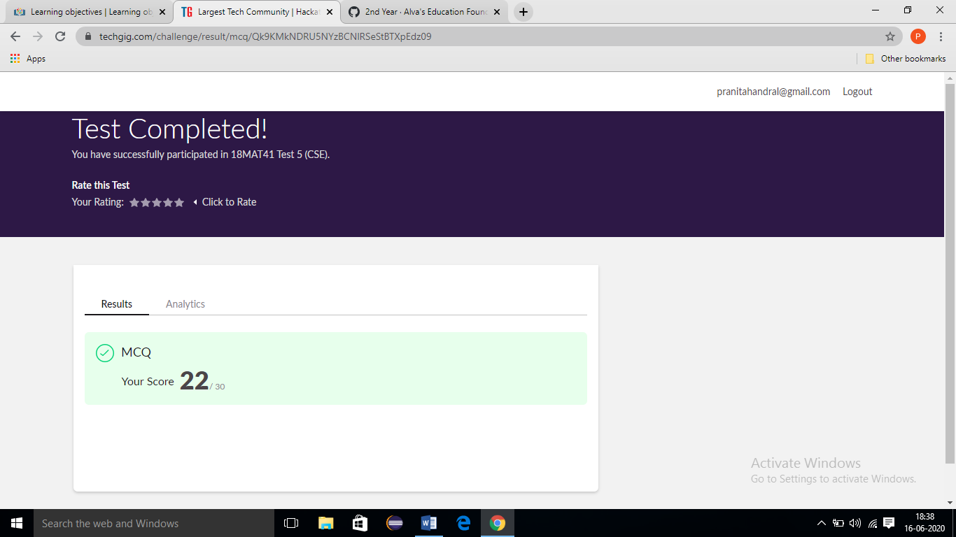

**Online Certification course Summary​:** I have taken my Online Certification Course in **Cognitive class**  the course which I have opted is **Blockchain Essentials**. Course contains videos, tutorials, assessments and quiz. Today I have gone **What is blockchain** and **The business context of blockchain.**

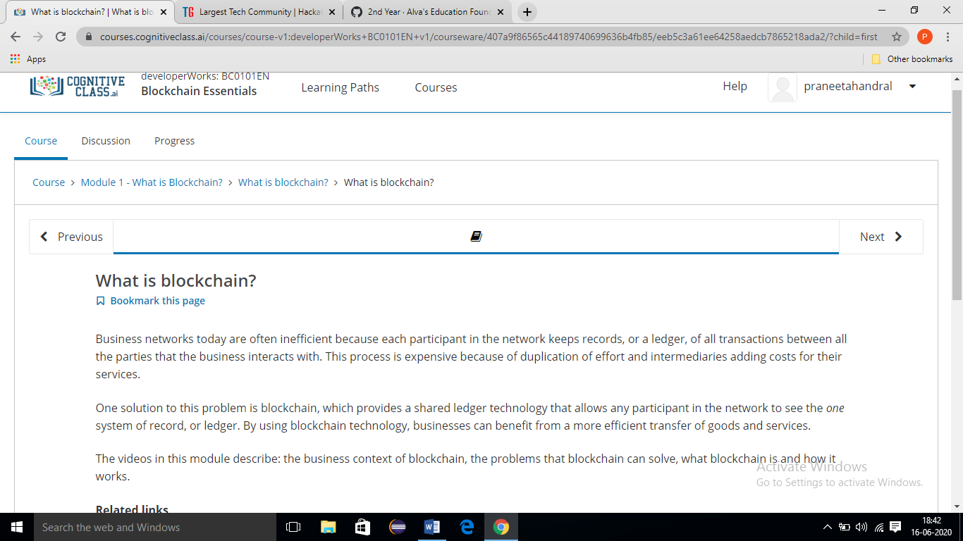

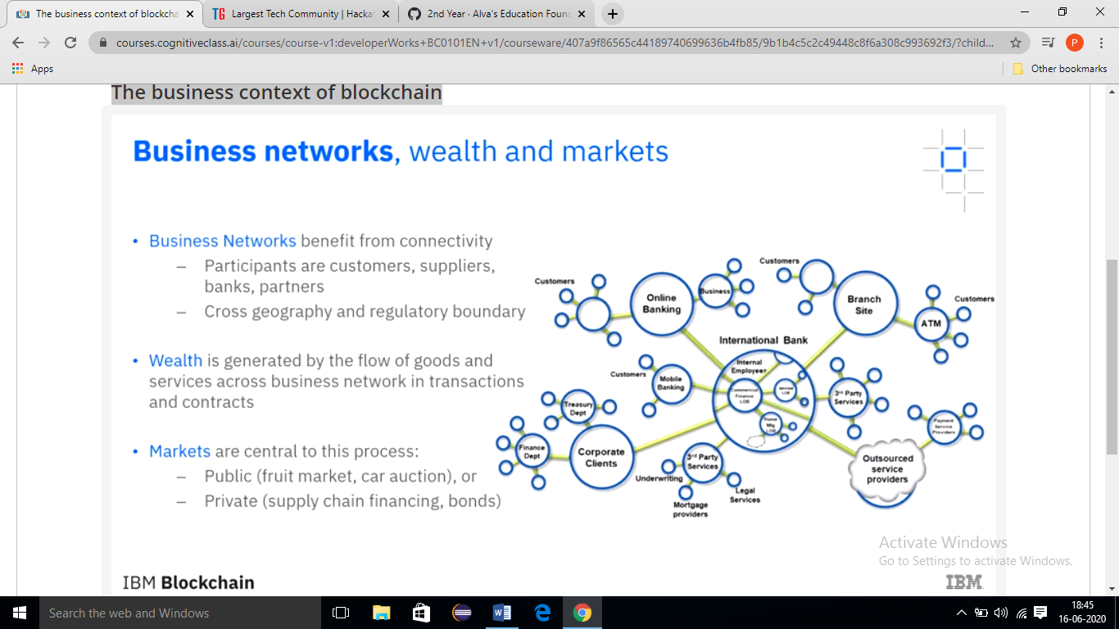

**Online Coding Summary​:** Today I received two programs from prof.Venkatesh CSE Dept. The ONE programs were. I have written one program and uploaded it to my Github repository. This is my repository snapshot. I have uploaded the frequency program.

